**UNIVERSIDAD NACIONAL ABIERTA Y A DISTANCIA**

**TASK 2 - WRITING**

**ANA MARÍA TIBADUIZA VEGA**

**1007826412**

**679**

**YANIRA DEL CARMEN ROSALES JURADO**

**Curso: Inglés A1 900001**

**SOGAMOSO**

**11 MARZO 2021**

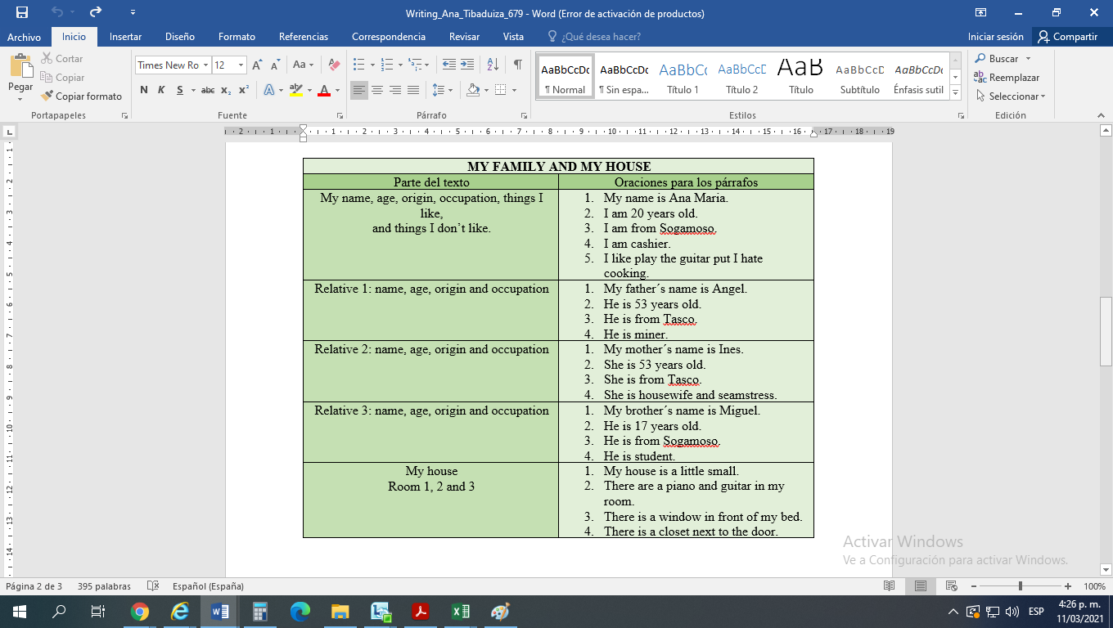 **TABLA ESTRUCTURACIÓN DEL ESCRITO**

**TEXTO CONSOLIDADO**

**H**ello, my name is Ana Tibaduiza. I am Colombian. I from Sogamoso. I am cashier. I speak Spanish. I am 20 years old. I like to play the guitar put I hate cooking. I am studying Music. My father´s name is Angel. He is 53 years old. He is from Tasco and he is miner. My mother´s name is Ines and she is 53 years old. She is from Tasco. She is housewife and seamstress. My brother´s name is Miguel. He is 17 years old. He is from Sogamoso. He is student. My house is a little small. My brother's room there is a small bed, there are anime drawing on the wall and there is a small table. In my parents room there is a big mirror in front of the door, also there is a wardrobe, there is a bed next to the window. There are a piano and guitar in my room, there is a closet beside the door and there is a computer on the table.